Part 1: Data Analysis and Insight
1. Data Overview
This dataset provides information about electric vehicles registered across different cities. It includes details such as the vehicle manufacturer, model, model year, and registration location.
The main purpose of this analysis is to examine trends and patterns in electric vehicle registrations. By analyzing the data, we can better understand which manufacturers are most popular, how electric vehicle adoption has changed over time, and which cities have the highest number of registrations.
2. Data Cleaning
During the data cleaning process, missing values in essential columns like “Vehicle Identification Number”, “City”, “Model Year”, “Make”, and “Model” were removed to keep the data accurate. I also spotted and cleared out duplicate rows to make sure the dataset is clean and reliable. Finally, the “Model Year” column was changed to an integer format for better consistency.
3. Descriptive Statistics
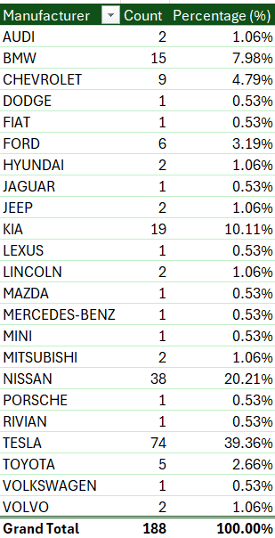
Table 1: Descriptive Statistics Summary
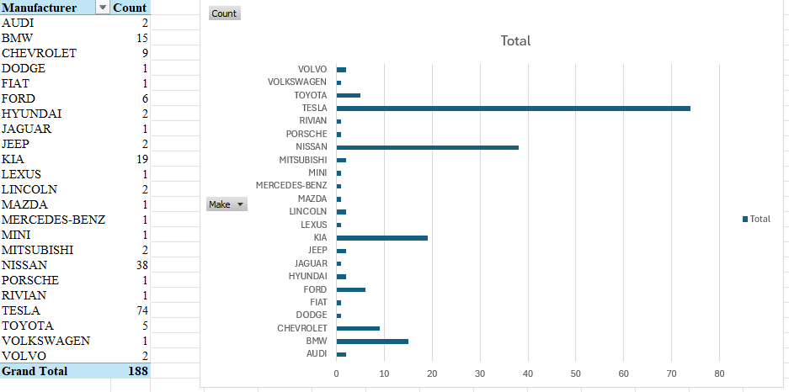
Figure 1: Most common manufacturers
Insight 1
Tesla has the highest number of vehicles in the dataset, with 74 out of 188 observations, far exceeding other brands such as Nissan (38 vehicles) and Kia (19 vehicles). This suggests that Tesla has a much stronger presence in the dataset, which may reflect higher consumer demand and the increasing popularity of electric vehicles in the automotive market.

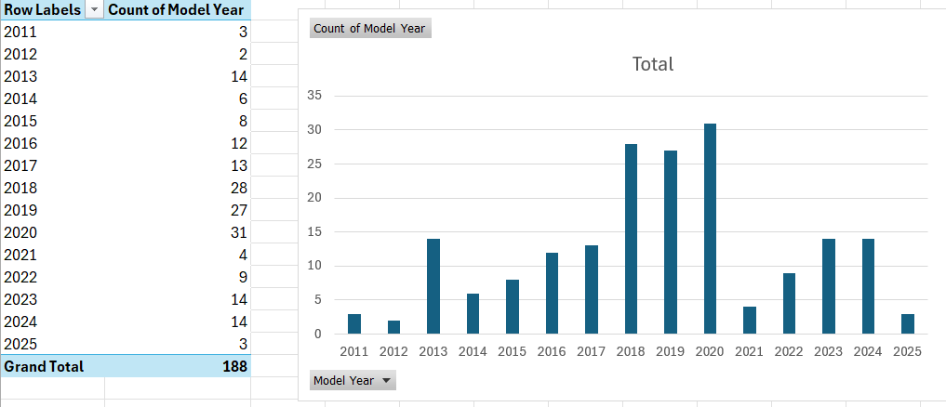
Figure 2: Model year distribution

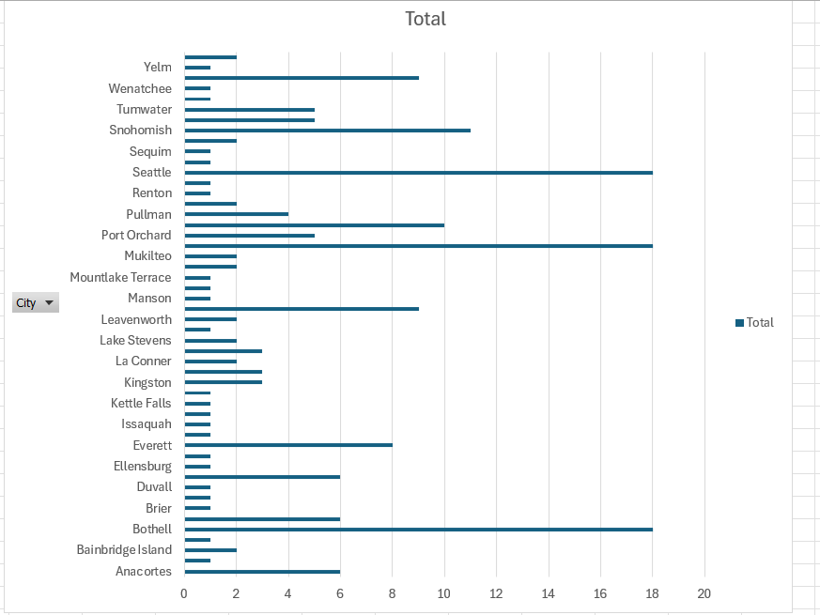
Figure 3: Cities with the Highest Number of Electric Vehicles

Insight 2
The visual representations show that electric vehicle use has grown significantly in recent years, primarily concentrated in major cities. Distribution by year of manufacture reveals a sharp increase in registrations from 2018 to 2020, with 2020 having the highest number of vehicles, while the city graph shows Seattle, Mukilteo, and Bothell recording the largest number of electric vehicles. Overall, these findings suggest that the rapid growth of electric vehicles is largely driven by urban areas, where charging infrastructure, environmental awareness, and access to newer electric vehicle models are more developed.

